**22 Feb 2019** **The Weekly Bulletin of Rotary Club of Kathmandu Mid-Town** **bc-22.2/019**

|  |
| --- |
| C:\Users\Public\Documents\RIP T1819_EN.png |

District: 3292 Web:www.rotarymidtown.org.np Club Id: 26776

**FEBRUARY IS PEACE AND CONFLICT PREVENTION/RESOLUTION MONTH**

There can be no peace in the region while people are poor, with no access to education and training, health facility, clean water and sanitation.

Rotary clubs can contribute in supporting community projects, skill training, networking, and community education programs that are committed to improving lives and building stronger communities by addressing the root causes of violence and conflict, such as poverty, illiteracy, disease, and lack of access to clean water and sanitation.

**Club’s Weekly Meeting # 1477 held on Friday 15 Feb 2019**

Four young entrepreneurs: Rtr Amit Bajracharya, Nanda K Mandal, Pranita Chettri and Mid-Towner Rabi Karmacharya assembled for a round-table discussion, shared their experiences in their start-ups, narrated how they built up their confidence and dealt with challenges. Opportunities abound in every sector of the economy; what’s needed is commitment, dedication, and ability to identify and deal with the issues in order to get rid of hindrances; challenges are everywhere, one needs to be smart enough for successful enterprise. No ***ke garne!*** Seriously ***kaam garne* *!!***

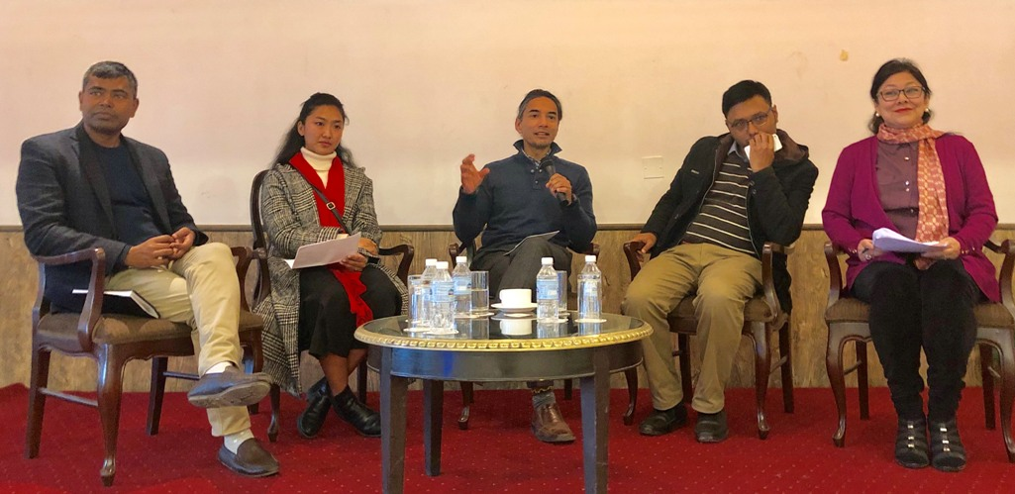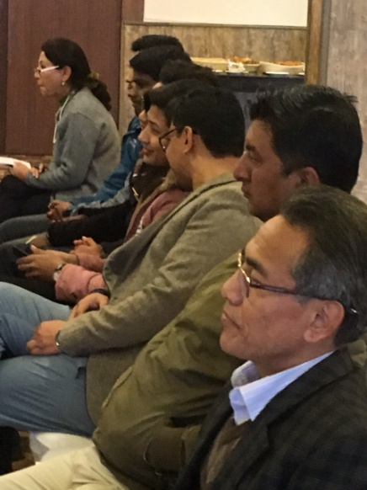

Round-table discussion in session audience

**Club Meeting # 1478 Friday 22 Feb**

Dr Richard Howard will be talking, as our guest speaker, on ILO activities in Nepal.

Dr Howard is the Director of ILO Country Office Nepal since 2016. He did his PhD in anthropology from Illinois University in 1996. Before coming to Nepal on ILO assignment he worked and contributed in different organizations, both in private sector and INGOs as research director, program manager, CTA, regional specialist on varied areas: gender equality, ethnicity, non-discrimination, migration, indigenous peoples, reproductive health and HIV, private sector partnership for health, industry analysis and market strategies.

**Mid-Town Team for Rotary Year 2019-20:**

President :  Neeva M Pradhan Immediate Past President : Jo Logghe

President Elect : Krishna NS Thapa

1st Vice President  : Lisa Choegyal 2nd Vice President : Dr Ganesh Gurung

Treasurer  : Ajaya R Sthapit (PP)  Secretary    : R.R. Shrestha (PP)

Joint Secretary :  Arun Man Sherchan (PP)

Committee Chairs

Administration : Walter Diller (PP) Membership : Mani D Joshi (PP)

Public Relations : William Ma (PP) Service Projects : Paras SJB Rana (PP)

Rotary Foundation: Dr Isabella Khadka Youth Service : Dr Chandra Lekha Tuladhar (PP)

Sergeant-at-Arms : Shyam Thapalia

**The Pillars of Peace:**

The Institute for Economics and Peace (IEP) is an independent, non-partisan, non-profit think tank dedicated to shifting the world’s focus to peace as a positive, achievable, and tangible measure of human well-being and progress.

IEP achieves its goals by developing new conceptual frameworks to define peacefulness; providing metrics for measuring peace; and uncovering the relationships between business, peace and prosperity as well as promoting a better understanding of the cultural, economic and political factors that create peace.

The Pillars of Peace is a new conceptual framework for understanding and describing the factors that create peaceful societies. This framework defines the national characteristics which are most closely associated with peace and has been derived from a process of statistical analysis. It stands as one of the few holistic and quantitative based studies to isolate the positive factors which sustain and reinforce peaceful societies.

The Pillars of Peace is an eight-part taxonomy which consists of:

- A well-functioning government;

- A sound business environment;

- An equitable distribution of resources;

- An acceptance of the rights of others;

- Good relations with neighbours;

- Free flow of information;

- A high level of human capital; and

- Low levels of corruption.

These eight Pillars were found to be associated with peaceful environments and are both inter-dependent and mutually reinforcing, such that improvements in one factor would tend to strengthen others and vice versa. Therefore the relative strength of any one Pillar has the potential to positively or negatively influence the others, thereby influencing peace.

*Read more on http://economicsandpeace.org*

**Peace Hero Award :**

Peace Hero Museums team organized a Peace Hero Museum Award Ceremony on Saturday afternoon (16 Feb) at Hotel Tibet International, Boudha. ***Mid-Towner PP Dr Chandra Lekha Tuladhar*** was one, among many others, recipient of Peace Hero Awards. The Awards were handed over to the Awardees by the founder of Peace Hero Museums, Liska Blodgett in recognition of social works and services provided by and the dedication of the Peace Heroes of Nepal. On the occasion she talked about the work that has been done over the past four years in Peace Museums in Vienna, Colorado and Rumania and also presented what the plans for future are: in one year Peace Museum Nepal will have a new home, at Swayambhunath Stupa. Congratulation to Dr Chandra Lekha Tuladhar.

~~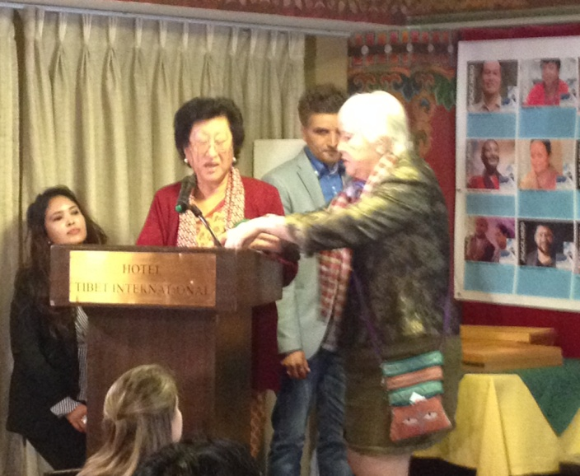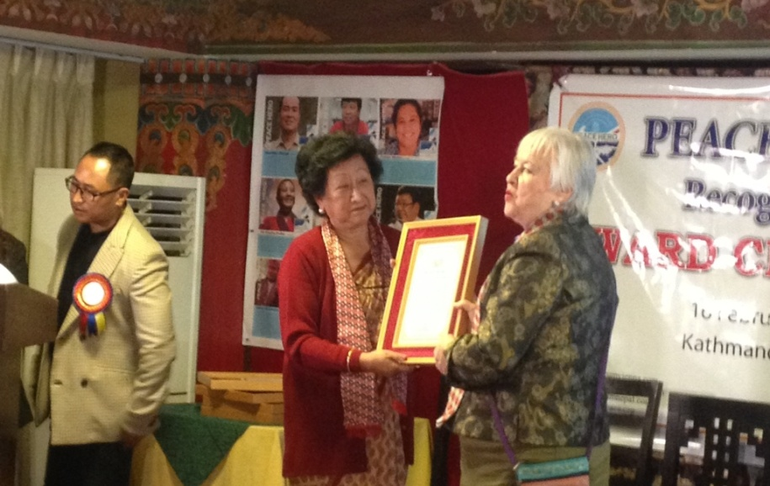~~

*For information on Peace Hero Museum Nepal, contact* *www.peaceheromuseumnepal.com*

**Do you Know ?**

**One copper coin fetched $ 1.38 million**

A one-cent copper coin minted in 1793, the first year that the United States produced its own coins, has fetched $1.38 million at a Florida auction. James Halperin of Texas-based Heritage Auctions told The Associated Press that the sale was "the most a United States copper coin has ever sold for at auction."

The Orlando Sentinel reports that the final bid by an unknown buyer for the coin was one of the largest sales at the Florida United Numismatists coin show and annual convention. The newspaper reports that the 1793 penny is rare and in excellent shape, showing no wear on its lettering, its Lady Liberty face or the wreath on its back. It came from the Mint in Philadelphia.

*https://* *www.deseretnews.com/article/70021336*

**A THOUGHT FOR THE DAY**

[I myself have never been able to find out precisely what feminism is: I only know that people call me a feminist whenever I express sentiments that differentiate me from a doormat.](http://www.brainyquote.com/quotes/quotes/g/georgewash106292.html" \o "view quote)

*[- Rebecca West](http://www.brainyquote.com/quotes/quotes/g/georgewash106292.html" \o "view quote)*

On Lighter Side:

A blonde and a redhead woman went to lunch. They had to wait for their table so they sat in the bar and had a drink. The TV was on and they noticed the news was showing a man on a rooftop threatening to jump. The redhead told the blonde "I bet you 50 bucks he jumps."

The blonde said “you're on.”

Sure enough, the man jumped; so the blonde started to dig out her money.

The redhead felt kind of bad, so she said “that's ok, I cheated. I saw this on the 10 o'clock news last night”.

The blonde said ‘Well so did I, but I didn't think he would jump twice in a row’!

If your club is transformational and well-organized, everything else will follow. Members

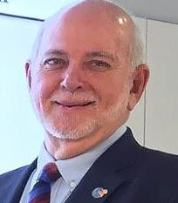

will be engaged, and new members will be eager to join you. Fundraising will be easier:

People love to give when they see how their money is making a difference and when they

know the organization is accountable. Your club will be vibrant, relevant, and alive — and it

will ‘Be the Inspiration’ to those within its ranks as well as to the community it serves.

**RI President Barry Rassin**

Please send information on club activities, progress reviews on service projects, relevant photos etc to:

BC Editor: RR Shrestha email: rryesrr@gmail.com

## 22 Feb 2019 The Weekly Bulletin of Rotary Club of Kathmandu Mid-Town bc-22.2/019